**Project Report**

On

**“Grain Storage Management System based on IoT”**

Submitted in partial fulfillment for the award of degree

of

**BACHELOR OF TECHNOLOGY**

In

**INFORMATION TECHNOLOGY**

Submitted by

**1. Ajay Doltade (15141216)**

**2. Ankita Kadam (15141124)**

**3. Sayali Honmore (15141123)**

**4. Mahesh Chandavale (15141210)**

Under the Guidance of

**Dr. S. J. Wagh**



**Government College of Engineering, Karad**

**(An Autonomous Institute of Government of Maharashtra)**

**Academic Year 2018-2019**

**Government College of Engineering, Karad**

**(An Autonomous Institute of Government of Maharashtra)**

**Department of Information Technology**

**CERTIFICATE**

This is to certify that the Project entitled **“Grain Storage Management System based on IoT”** is submitted under the supervision and guidance, of our project guide Dr. S. J. Wagh with partial fulfillment for the award of the BACHELOR OF TECHNOLOGY in Department of Information Technology from Government College of Engineering, Karad for the academic Year 2018-19 Sem. VIII

|  |  |  |
| --- | --- | --- |
| **Dr. S. J. Wagh** |  | **Dr. S. J. Wagh** |
| **Project Guide** |  | **Head**  **Information Technology**  **Department** |

**ACKNOWLEDGEMENT**

# Apart from individual efforts, the success of any project depends largely on the encouragement and guidelines of many others. We take this opportunity to express our gratitude to the people who have been instrumental throughout the project work.

# It is our privilege to express our gratitude towards our project guide, Dr. S. J. Wagh, for their valuable guidance, encouragement, inspiration and whole-hearted cooperation throughout the project work. We thank him for being a motivation through all our highs and importantly, our lows.

# We deeply express our sincere thanks to our Head of Department Dr. S. J. Wagh for encouraging and allowing us to present the project on the topic “Intelligent Grain Storage Management System” and providing us with the necessary facilities to enable us to fulﬁll our project requirements as best as possible. We take this opportunity to thank all faculty members and staff of Department of Information Technology, who have directly or indirectly helped our project.

# We pay our respects to honorable Principal Dr. A. T. Pise for their encouragement. Our thanks and appreciations also go to our family and friends, who have been a source of encouragement and inspiration throughout the duration of the project.

**ABSTRACT**

India is an Agriculture country where 70% of the population depends on farming, the storage of grains plays a crucial role in national economy. During the grain storage, temperature, humidity and carbon dioxide concentration are major ecological factors that can influence the quality of the stored grain inside the go-downs and warehouses. The traditional methods are limited to simple manual temperature and humidity testing which are relatively backward as the other factors have to be checked and monitored independently for contributing to their effective storage and maintenance.

The Real-time monitoring of the grain storage system is designed by using Digital Humidity and Temperature sensor (DHT11), Smoke Sensor (MQ2), Carbon Dioxide Sensor (MQ135) and Motion Sensor (PIR) based on IoT. Also the Blynk application will regularly update the system through notifications in continuous time stamps. The experimental results shows that the intelligent grain storage management system designed in this paper has several good features such as realtime online detection, regular updation and easy system maintenance. This improves the level of grains storage, reduce the grain losses during storage procedure and also reduce man power and labour intensity.

**Keywords: IoT, Blynk, MQ135, MQ2, PIR**

**LIST OF FIGURES**

|  |  |  |
| --- | --- | --- |
| Sr. No. | Figure | Page No. |
| 4.1 | Proposed Architecture of Grain storage Management System | 8 |
| 4.2 | Internal Logic of Grain Storage Management System | 9 |
| 4.3 | Level-0 DFD | 10 |
| 4.4 | Level-1 DFD | 11 |
| 4.5 | Level-2 DFD | 12 |
| 4.6 | Use case Diagram of Grain storage management system | 13 |
| 4.7 | Sequence Diagram of Grain storage management system | 14 |
| 4.8 | Collaboration Diagram of Grain storage management system | 15 |
| 4.9 | Activity Diagram of Grain storage management system | 16 |
| 4.10 | State Diagram of Grain storage management system | 17 |
| 4.11 | Deployment Diagram of Grain storage management system | 18 |
| 4.12 | ESP8266 Microcontroller | 19 |
| 4.13 | Arduino Nano | 19 |
| 4.14 | DHT11 Sensor | 20 |
| 4.15 | MQ135 Sensor | 20 |
| 4.16 | MQ2 Sensor | 20 |
| 4.17 | PIR Sensor | 21 |
| 4.18 | Relay Module | 21 |
| 4.19 | Fan | 22 |
| 4.20 | Buzzer | 22 |
| 4.21 | ThingSpeak | 22 |
| 4.22 | Blynk | 22 |
| 5.1 | Interaction with shop owner at field of deployment | 27 |
| 5.2 | Shop owner using system application | 28 |
| 5.3 | Project team with shop owner | 28 |
| 6.1 | Output on Desktop System | 29 |
| 6.2 | Output on Blynk application with notifications | 30 |
| 6.3 | Automatic Generated Data Sheet | 31 |
| 6.4 | Output on Desktop application | 32 |
| 6.5 | Output on Blynk application | 32 |

**ABBREVATIONS**

|  |  |
| --- | --- |
| Acronym | Definition |
| IOT | Internet of Things |
| DHT | Digital Humidity and Temperature |
| PIR | Passive Intfra-Red |
| API | Application Program Interface |
| ADC | Analog to Digital Converter |
| LCD | Liquid Crystal Display |
| GPIO | General Purpose Input Output |
| FAO | Food and Agricultural Organisation |
| ARM | Advanced RSIC Machine |
| RISC | Reduced Instruction Set Computer |
| HTTP | Hypertext Transfer Protocol |
| USB | Universal Serial Bus |

**TABLE OF CONTENTS**

Topics Page No.

* Abstract i
* List of Figures ii
* Abbreviations iii

|  |  |  |
| --- | --- | --- |
| Sr. No. | Table of Contents | Page No. |
| Chapter 1 | Introduction…………………………………………….. |  |
| 1.1 | Background | 1 |
| 1.2 | Importance of Project | 1 |
| 1.3 | Motivation | 2 |
| 1.4 | Scope | 3 |
| 1.5 | Expected Outcomes | 4 |
|  |  |  |
| Chapter 2 | Literature Survey………………………………………… |  |
| 2.1 | Intelligent System for Monitoring and Controlling Grain Condition Based on ARM 7 Processor | 5 |
| 2.2 | Grain Storage Management | 5 |
| 2.3 | Efficient Food Storage Using Sensors, Android and IoT | 6 |
|  |  |  |
| Chapter 3 | Related Theory and Problem Definition…….…………… |  |
| 3.1 | Problem Definition | 7 |
| 3.2 | Related Theory | 7 |
|  |  |  |
| Chapter 4 | Design Methodology………………………...................... |  |
| 4.1 | Proposed System Architecture | 8 |
| 4.2 | Internal Logic of System | 9 |
| 4.3 | Data Flow and UML diagrams | 10 |
| 4.4 | Technical Specifications | 19 |
|  |  |  |
| Chapter 5 | Implementation…………………………………………… |  |
| 5.1 | Implementation of Grain Storage Management System | 23 |
| 5.2 | On-field Testing | 27 |
|  |  |  |
| Chapter 6 | Result and Discussion…………………………………… |  |
| 6.1 | Result | 29 |
| 6.2 | On-field Result Analysis | 30 |
| 6.3 | Discussion | 33 |
|  |  |  |
| Chapter 7 | Conclusion and Future Scope……………………………. |  |
| 7.1 | Conclusion | 34 |
| 7.2 | Future Scope | 34 |
|  |  |  |
|  | Paper Published…………………………………………... |  |
|  | References………………………………………………… | 35 |
|  |  |  |

**Chapter 1**

**INTRODUCTION**

**1.1 Background:**

In many countries Grains are the main source of food and many staple food products are prepared from them, so every human life depend on Grains food products for survival in one or the other way. Hence cultivation and storage of grains plays a crucial role in national economy and overall development of the society. Economies of developed and developing nations depend directly or indirectly on storage of cultivated grains since they are related to the several hundreds of millions of people.

Maintaining threshold temperature, proper humidity and relative carbon dioxide content in the storage environment are the important problems faced in Go-downs. The fluctuations in seasonal and daily environment influence the quality of grain and these are reasons to increase mold growth, insect activities. Inside the go-down, the mold growth accours at around 25-30°C threshold tempearture, insect growth and reproduction occurs at ideal temperature of 15°C and above. Insect metabolic activity in dry storage below 15% moisture content can result in heating up to 42°C [5]. A major factor that contributes to the grain spoilage is growth of various mold species which release mycotoxins. Fungi produces natural chemicals called mycotoxins that are hazardous to grain health. These activities release CO2 gas in the stored grain. Hence, CO2 concentration is the effective factor to determine the early spoilage stage of stored grain [5].

**1.2 Importance of the project:**

As we know the condition of maintaining the grain storages are degrading due to the lack of proper maintenance and the good ecological conditions. If the natural disorder or any emergency occurs then it is the major issue to make all the people available with enough amount of grain supply to feed themselves during this conditions. So, there should be abundant amount of grain storage in government or private sector go-downs at different level e.g. regional, district, state and at national level. So it is the need of age, to maintain the go-downs at balanced environmental conditions and with less manual attention to prevent the entry of fungal disease and also the man made disorders.

Temperature records help you, the grain manager, to redress speedily to changes occurring inside the grain. Whether grain is warm or cool, changes in temperature can be the first signal of feasible problems. Grain is a very good conductor, thus the centre survive warmer longer. Humidity migration may occur in any storage tank. It is caused by differences in grain air temperatures. Air currents always take the path of minimum obstruction. In the fall, the cold air on the outside of the bin (cold air is heavier) pushes the warmer air into the centre of the bin where it moves upward and eventually encounters the cool air at the top. This results in compaction and crusting. The inverse may take place in the Spring and Summer, with condensation and impairment occurring at the base of the bin. Temperature monitoring cables supply the information needed to help keep temperatures identical throughout the bin, removing moisture transference.

The project of Grain Storage Management System based on IoT will provide the efficient way to maintain the grain stored in governmental or private warehouses in good content with maintaining their nutritional level and with less wastages. The system will monitor, detect, analyse and control all those accidents happening in the go-downs. The developed product will help to monitor the go-down through the various sensors and microcontroller that will reflect the data on the desktop system automatically. According to that data, the caretaker or mentor will comes to know the conditions inside the warehouse. If the content shown on desktop system is beyond the threshold contents then he can take the proper steps to recover the management. Also the android application will regularly provide the notifications to the remote owner or the manager about the warehouse. If in case of any emergency like fire or leakage etc. occurs then the control system will provide the alert notifications to the caretaker by turning on the buzzer. As, the temperature, humidity and atmospheric gases plays important role in the growth of insects inside the stored grain, hence monitoring the level of this factors inside go-downs will be the main goal of this system. The temperature above 15°C (Celsius) will be suitable condition for the growth of insects, hence the system will maintain the grain storage always below that threshold temperature [5]. Also if the animal enters the go-down then, the sensor will capture the undesired movements inside go-down and will alert the caretaker about such unwanted entry. All these activities will efficiently help the vendor to maintain the storage of grain at proper situation without their loss and with less manual attention.

**1.3 Motivation:**

The motivation behind this project ‘Grain Storage Management System based on IoT’ comes from the observations about the lack of availability of the food for the people in case of some natural disaster or drought. Due to which the cost of food rises to the highest level which are not offered by the people in society. Although, India has very strong Agricultural background and the production of grain quantity is also to the highest peak, the problem of less availability of stored grain is every year’s issue. The produced grain got wasted due the unproper treatment inside the warehouse and go-downs. Not only the production is important but their maintenance is far way more important. Hence it is the need of age to take good care of the grain stored inside the go-downs. Grain storage is carried out basically to maintain the quality of grain after harvest for retaining the viability of the grain for planting in the following season, maintaining the supply of grain and taking advantages of higher prices by farmers, government and industry [6]. Hence, the thought of this project lies behind this concepts and comes with the good solution over the problem of grain storage and management.

Now-a-days the people are still using our traditional methods to store the grain produced through cultivated crops and their maintenance and observation is done by simple manual techniques including the temperature and humidity testing. Usually their maintenance is done by several methods as ventilation, drying and cold storage which are relatively backward and causes more amount of grain wastage and also the manpower cost. The advance technology gives rise to developing real-time monitoring system of remote locations, which makes it easier to control and monitor conditions from any place at any time.

**1.4 Scope:**

Like other living things, the lifetime of grain depends mainly on the respiration of air and in the absence of air it becomes sick. Additional moisture, excessive temperature, and improper grain storage condition are considered as most important factors resulting in stored grain wastage at greater amount.

The proposed system will able to overcome all the basic requirements and quality levels of the go-downs to prevent the stored grains at their proper nutritional level and with less wastages. The stored grain will be continuously and regularly monitored through the sensors 24*7. The reporting of any undesired effects inside, will be automatically and quickly informed to the vendor and the manager at any time whether in local area or remote area. In case of any emergency the vendor will be properly instructed by the system and hence the vendor can control the losses and maintain system under control. So, with help of this product the government and owners of go-downs will reach to their expected satisfaction level and fully relay on the system.

**1.5 Expected Outcome:**

* The system proposed through this architecture will provide the efficient way for grain storage and will reduce the wastage of grains due to the unhealthy atmosphere at the storage area.
* The system will guide about all the necessary conditions and suitable environment for the better preservation of grains in order to maintain their good quality.
* The sensors will regularly display the updates regarding the storage area and will provide alerts to the handler in case of any emergency. The android application will notify the user through regular time stamps.
* As the grains are in good quality hence the future it will serve the need of age.

**Chapter 2**

**LITERATURE SURVEY**

* 1. **Intelligent System for Monitoring and Controlling Grain Condition Based on ARM 7 Processor [1].**

The author Vinayaka and Roopa had proposed a system for monitoring and controlling the grain conditions. The aim of grain storage facility is mainly to provide safe storage condition and to maintain quality of stored product. Grain loss occurs by adverse environmental conditions and from the activities of insects and microorganisms.

The general model proposed for grain storage framework comprised of two parts, one is the host PC which assembles Grain environment i.e. Sensor data, it procedure and forecast of grain circumstance, the other one lower level control terminal in the silo/depot with grain information obtaining. Hence, the proposed system involves the use of ARM7 processor, LPC2148 and different types of sensors. The parameters such as temperature, humidity and carbon dioxide percentage is displayed on the interface. If the values are above certain threshold conditions then controlling actions are taken manually.

The recent technology allow to develop the system which can monitor and store the grain in good condition with less efforts. Using IoT, the solution over the wastage of grain is provided in great extent. It makes easier to monitor, control and observe the system from any time and any place.

* 1. **Grain Storage Management [2].**

The author Can Burak Sisman and Selcuk ALBUT states that, it is difficult to improve the quality of stored grain but maintaining its initial quality can be done. When condition of stored grain starts degrading, it is usually the collective result of various management activities that include initial condition of grain, temperature and moisture migration, aeration and monitoring grain condition. Grain store best if they are cool, dry and clean. Mold growth and insect activity are dependent on both temperature and grain moisture content. It is not easy to cool down grain from warmer atmosphere or summer storage temperatures. Keeping grain temperatures below 60º F as long as possible will help minimize insect activity and mold growth. Moisture content is one of the most important criteria effective on the spoilage during storage.

In this paper author had not mentioned the use of sensors for monitoring grain condition hence it will monitor it bi-weekly or according to seasonal requirement. So, there is not any actual correctness. By using sensors and microcontroller with help of various internet based applications and server, we can automatically monitor the system. Also use of cloud based services for storing, analyzing data will make thesystem more efficient and proper decision oriented.

* 1. **Efficient Food Storage Using Sensors, Android and IoT [3]**

The author of paper had proposed the food storage system based on IoT and different sensors for observing the temperature, humidity and other ecological conditions inside the food distribution center. The proposed method of author is a special case of introducing an android app using which the various environmental conditions like temperature, smoke, humidity, light can be sensed and can be stored in a database. DHT11 sensor monitors for any change in temperature and humidity within the go-down area, whereas MQ135 gas sensor is used to detect CO2 concentration emitting from decaying of grain. LDR sensors are placed at storage locations, since stored grain requires proper lighting. If the surrounding environment is changed, LDR sensors generate voltage ranges. These output voltages are provided to the pins of ADC unit of the microcontroller for the further processing.

**Chapter 3**

**RELATED THEORY AND PROBLEM DEFINITION**

**3.1 Problem Definition:**

As, we can see the quality of stored grain in go-downs degrades due to the un proper handling and less care taken. The grain have to face the attacks of insects or moulds. This increases the wastage of grain at higher extent.

Mold Activity: Stored grain mostly get infected by the large varieties of mold at certain extent. Temperature and Moisture will enhance mold growth and reduces the quality of stored grain. The mold releases mytotoxins which in turn increases concentration of CO2 during storage. [6]

Infestation: The temperature of stored grain is always increased by Insect activity. Insect reproduction gives rise to in warm grain. Hence certain rise in temperature can be the detective measure against insect growth. [6]

So, the important factor which leads to above harmful conditions are temperature and humidity. So the main goal of grain storage and management system is to maintain the stored grain at proper temperature and humidity level within its threshold value. As, the grain and the food produced are the ultimate source to feed the human beings in well manner. So, it forms the higher responsibility to store and take care of the food with more efforts and proper care.

**3.2 Related Theory**

Now-a-days grain storage organisations are facing problems in availability of various quality maintenance techniques such as refrigeration system, cold storage or freezing in order to preserve the quality of stored grain [5]. Although India has tremendous amount of production rate of grain, the sustaining rate is not in that equal ratio. The produced quantity goes on wastage due to the improper care taken by the government or private sector warehouses [1]. The traditional methods are still used today to store the grain inside go-downs but these techniques fails in many ways as the important parameters remains unmonitored. The crucial parameters for effective storage and usage in future should be covered while their storage conditions. Hence it becomes the responsibility of management to maintain the conditions inside the go-downs well in manner in order to preserve the quality of stored grain.

**Chapter 4**

**DESIGN METHODOLOGY**

**4.1 Proposed system Architecture:**

The proposed system of intelligent grain storage and management mainly includes the two divisions as hardware and software.

* Hardware: The hardware part encompasses of microcontroller ESP8266 and Arduino nano, the sensors which are DHT11, MQ135, MQ2 and PIR sensor. For the controlling actions the Buzzer, relay and fan is used which will provide the alerting notification to the manager. The sensors will capture the data in the surrounding area and will send it as input to the ThingSpeak database over cloud. The data received will be input to the system for the next controlling actions. The API reference key generated over ThingSpeak act as interfacing medium between hardware and software.

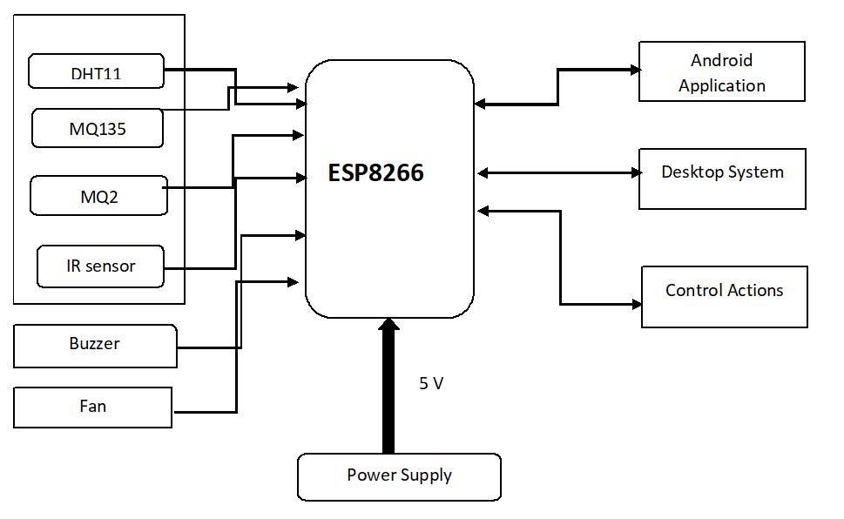

Fig. 4.1 Proposed architecture of Grain storage management system

* Software: This part mainly comprises of the desktop system and android application. The desktop system is nothing but the overview of the go-down and its environmental conditions inside. ThingSpeak server performs the functions of desktop system. The desktop system will provide the information regarding with captured data. The data will be in the format of graph or chart of table. The desktop system works for the monitoring the go-down through local area. The overall data of monitored parameters will be stored in the .csv file for the future purposes. If the manager of go-down goes to the remote area then the android application will serve the purpose of maintenance. The regular notifications over the android application are sent through the blynk server so that the manager will come to know about the recent situations in go- downs. So the software serves the important purpose of controlling actions.

**4.2 Internal Logic of system:**

The grain storage management system consists of various sensors and the microcontroller unit ESP8266 and Arduino nano. The sensors used are DHT11 (Digital Humidity and Temperature), MQ135, MQ2 and PIR sensor. For the controlling actions the buzzer and fan will provide alerting alarms to the vendor. The notification over blynk applications will be delivered regularly through blynk server used.

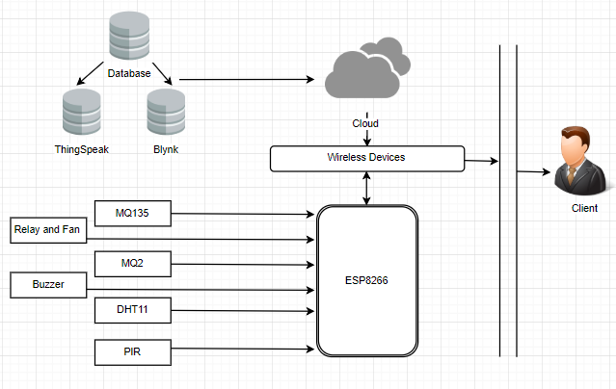

Fig 4.2 Internal Logic of Grain Storage Management System

As the above diagram shows, the sensors MQ135, MQ2, DHT11 and PIR are connected to the ESP8266 .The database comprises of ThingSpeak and Blynk which are stored independently on respective clouds. The wireless devices which are desktop system and blynk application will capture those monitored data from cloud and will serve the system accordingly. The grain storage management system is composed of whole hardware and software part mentioned above. Hence, at the completion of system it will overall handover to the client. The client can make use of the circuit box and will monitor their go-down with the help of wireless devices. If the parameter conditions goes beyond threshold values then controlling actions will be taken place automatically by the system.

**4.3 Data Flow and UML Diagram**

**4.3.1 Data Flow Diagram:**

Data flow diagram maps the flow of information for any process or entity. The dfd diagram have predefined symbols such as rectangle, circle, double arrows with text to show entities, processes and flow of data within system. The dfd flow can vary from simple hand drawn path to multilevel in-depth data flow.

Level 0 DFD:

Level 0 dfd shows the simple path of data within the system. The data path shows the flow form hardware to client. The grain storage management system captures the inputs from hardware and server and it shows output to the client.

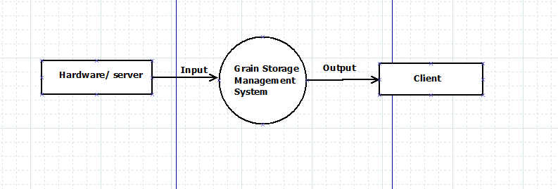

Fig. 4.3 Level 0 DFD

Level 1 DFD:

Level 1 DFD elaborates the level 0. It shows the data flow within the system with more details. In level 1, the entities database or server sends data to system. Sensors and microcontroller captures data for monitoring. Desktop system and android application displays captured data. According to data the report will be generated and controlling actions will be taken over.

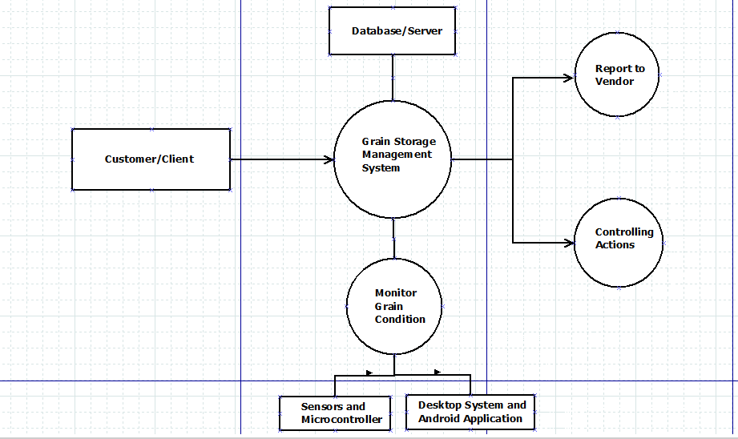

Fig. 4.4 Level 1 DFD

Level 2 DFD:

Level 2 DFD shows the most detailed path of data within the system. It elaborates the level 1 of DFD. The entities involved in level 2 are client, vendor, On screen data, Fan and buzzer. Firstly system does authentication of server with help of auth keys. The system captures the data from various sensors and monitors it. The captured data is displayed on Screen. The notifications and alerts are generated depending on the captured data. Fan and buzzer are provided for the controlling actions. During the successful running of system the report is generated in the form of .csv file. The report will be provided to vendor in order to check the system’s parameters.

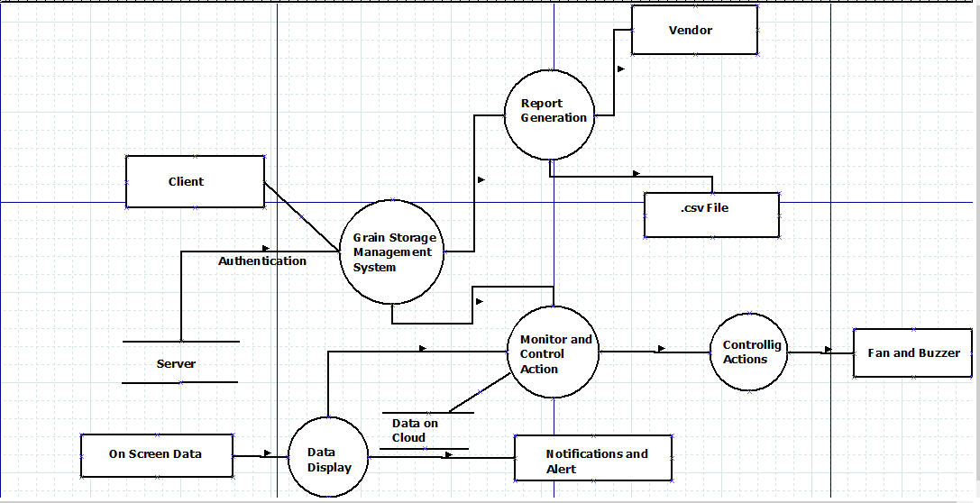

Fig. 4.5 Level 2 DFD

**4.3.2 Use Case Diagram:**

A use case diagram is a graphical representation of the interactions among the elements of a system like actors, relationships etc. A use case is a methodology used in system analysis to identify, clarify, and organize system requirements. Use case diagrams are employed in UML (Unified Modeling Language). Use case diagram is one of them and its specific purpose is to gather system requirements and actors. Use case diagrams specify the events of a system and their flows. But use case diagram never describes how they are implemented.

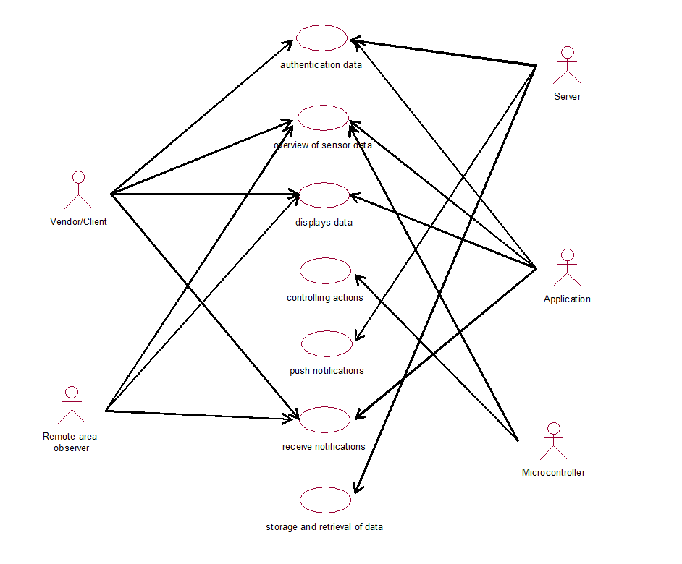

Fig 4.6 Use case Diagram for grain storage management system

Above use case diagram there are five actors namely server, application, microcontroller, vendor and remote area observer. Use cases are represented by ovals. Each use case represents the required function which are supported by given actors. A use case describes how actors uses a system to accomplish a particular goal. To authenticate data, display of data, receive notification, push notification, controlling actions such use case define the relationship between the system.

**4.3.3 Sequence Diagram:**

Sequence Diagrams are interaction diagrams that detail how operations are carried out in the project process. It shows high level interaction between active objects in the given system. The elements in sequence diagram interact over time and they are arranged according to object (horizontally) and time (vertically). These diagrams are widely used by businessmen and software developers to document and understand requirements for new and existing systems.



Fig. 4.7 Sequence Diagram of grain storage management system

In above sequence diagram there are four objects which are application, server, microcontroller and sensors. Firstly blynk application authenticate with server and microcontroller. Then request of current status get thorough sensors and send to the server and then the data and control notifications display on the application and desktop system.

**4.3.4 Collaboration Diagram:**

A collaboration diagram is a type of visual presentation that shows how various software objects interact with each other within an overall IT architecture and how users can benefit from this collaboration. A collaboration diagram often comes in the form of a visual chart that resembles a flow chart. It can show, at a glance, how a single piece of software complements other parts of a greater system.



Fig. 4.8 Collaboration Diagram of grain storage management system

It defines the role of the actors they perform a particular flow of the process of a use case. Sequence diagrams and collaboration diagrams express similar information, but show it in different ways. Collaboration diagram shows the direct interaction between the objects.

**4.3.5 Activity Diagram:**

An activity diagram is a graphical representation of an executed set of procedural system activities and a state chart diagram variations. Activity diagrams describe parallel and conditional activities, use cases and system functions at a detailed level. An activity diagram is represented by shapes that are connected by arrows.

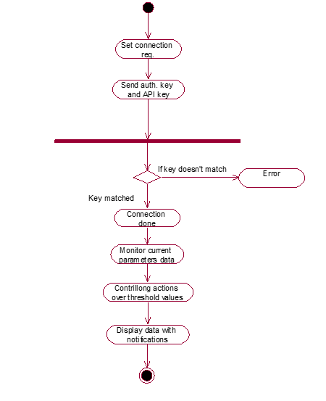

Fig. 4.9 Activity Diagram of grain storage management system

Arrows drawn from activity start to completion of the activity and represent the sequential order of performed activities in the system. There are four important points which will identify before drawing the activity diagram activities, associations, conditions, constraints. How the process flows if key doesn’t match then there is error. If the key is matched then it will go to next activity.

**4.3.6 State Diagram:**

This diagram describes th behaviour of a system considering all the possible states of an object when an event occurs. This behaviour is represented in a series of events that occur in one or more possible states. Every diagram shows objects and tracks the various states of these objects throughout the system.

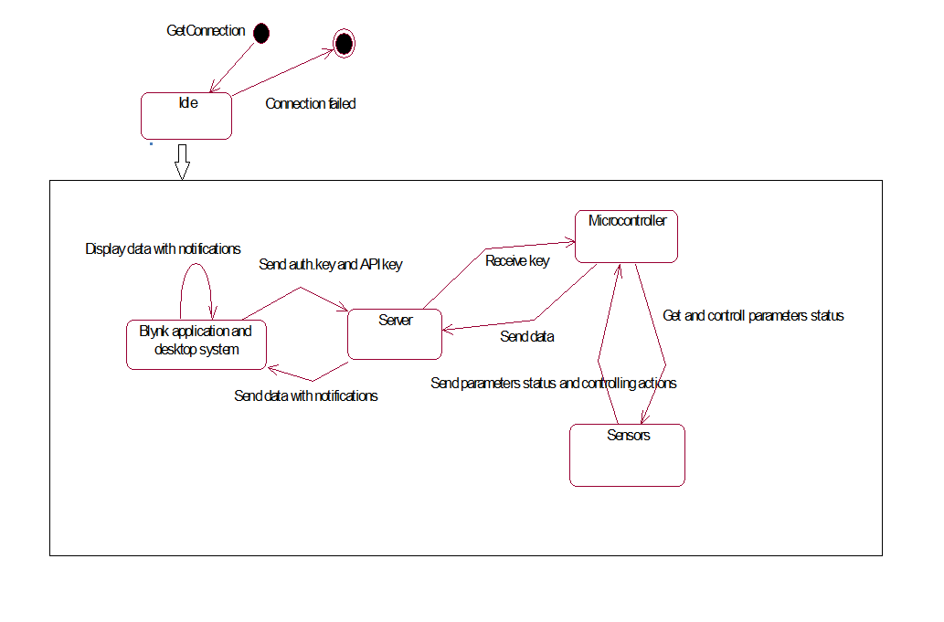

Fig. 4.10 State diagram of grain storage management system

This diagram shows each and every transition of the system. Firstly connection request is checked if is ts connected then it goes to next step otherwise connection get failed. At the state of blynk application and desktop system it send the authentication key to the server for verification process. After authentication is done server send/receive Data from microcontroller/hardware state. In this state microcontroller get and control parameter status through sensor state. In this way state transition takes place.

**4.3.7 Deployment Diagram:**

Deployment diagram is structure diagram which shows architecture of the system process as distribution of software artifacts to deployment targets. Deployment diagram usually drawn during implementation phase of the development of the system. It shows the physical arrangements of the nodes in the deployment system. Deployment diagram mainly focus on configuration of the runtime processing nodes.

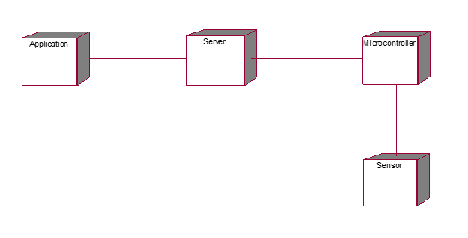

Fig. 4.11 Deployment diagram of grain storage management system

In above deployment diagram we represent four run time nodes namely application node, server node, microcontroller node and sensor node. It shows physical arrangement of the system architecture during implementation phase.

**4.4 Technical Specifications**

The technical specifications of all the components used in Grain Storage Management System are listed as below:

**Hardware:**

* ESP8266: It is an open source IoT firmware used for number of various IoT applications. It includes 30 GPIO pins for the connection to the other hardware parts. It has inbuilt WiFi module for transmitting data over server.

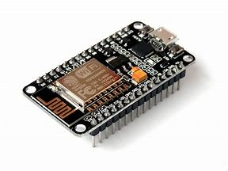

Fig. 4.12 ESP8266 Microcontroller

* Arduino Nano: The Arduino Nano is a micro, complete, and simple circuit board based on the ATmega328. It does not have DC power jack. The Arduino Nano can be powered via the Mini-B USB cable. Highest voltage source is automatically selected as a power source.

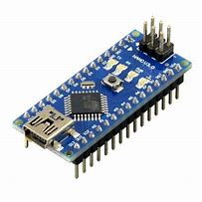

Fig. 4.13 Arduino Nano

* DHT11: It is the sensor used to measure the atmospheric temperature and humidity. IT will sense the present condition and level of temperature and humidity in surrounding area and will display the data accordingly to the input. To store the grain safely, temperature is the key. When condition of stored grain goes beyond control, there is always an unusual increase in temperature. Hence, for the better maintenance of grain storage, temperature is the best indicator of grain quality [6].

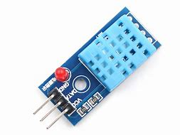

Fig. 4.14 DHT11 sensor

* MQ135: MQ gas sensor series is used to measure the amount of atmospheric gases in area. In particular, MQ135 specifically measures the amount of carbon dioxide in the surrounding. The amount of carbon dioxide is the main factor to investigate about the formation of insects or disease inside go-downs.

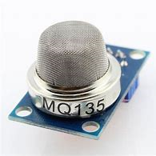

Fig. 4.15 MQ135 sensor

* MQ2: MQ2 is the smoke detector. It measures the amount of fire gases in surrounding. If in case of emergency like fire, the sensor will observe the amount of smoke inside go-down [5].

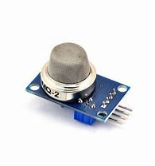

Fig. 4.16 MQ2 sensor

* PIR sensor: It is Infrared sensor, used to detect the movements inside the go-down. If certain animal such as mouse or rat enters inside the go-down, then those undesired movements will be counted by PIR sensor and depending upon that the vendor will be informed.

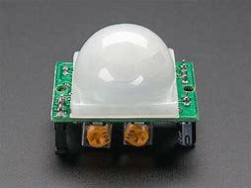

Fig. 4.17 PIR sensor

* Relay: A relay is an [electrically](https://en.wikipedia.org/wiki/Electric) operated [switch](https://en.wikipedia.org/wiki/Switch). Relays are used where it is necessary to control a circuit by a separate low-power signal, or where several circuits must be controlled by one signal.

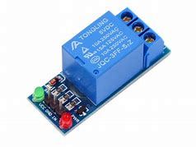

Fig. 4.18 Relay Module

* Fan and Buzzer: Fan and Buzzer are used for controlling actions. When the temperature level rises above the threshold values the Fan will be turned ON. If the fire is dected inside the go-down, the buzzer will be ring in order to indicate the vendor about emergency.

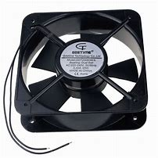

Fig. 4.19 Fan

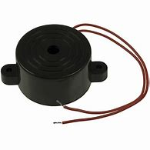

Fig. 4.20 Buzzer

**Software:**

* ThingSpeak Cloud: ThingSpeak is an open source IoT application and [API](https://en.wikipedia.org/wiki/API) cloud to store and retrieve data from things using the [HTTP](https://en.wikipedia.org/wiki/HTTP) protocol over the Internet. The data captured from sensors is displayed on the window of ThingSpeak indicating the status of environment.



Fig. 4.21 ThingSpeak

* Blynk Android application: The blynk application is developed through the blynk platform by creating new project. The application will be updated regularly through the notifications sent over blynk cloud with certain time stamp.



Fig. 4.22 Blynk

**CHAPTER 5**

**IMPLEMENTATION**

* 1. **Implementation of Grain Storage Management System:**

Software:

Here, we use Arduino IDE software for writing program. With the help of Arduino IDE we write and compile program. After successfully compilation of program we deploy or upload the compiled code on ESP8266 NodeMCU microcontroller board. During uploading we select port as COM3, and device platform as a NodeMCU. In Arduino IDE we include Blynk, DHT11.h and related libraries. For Monitoring and controlling purpose we use another software platform such as ThingSpeak for desktop system and Blynk application. All data is stored and analysed on cloud. Here, we use free and user friendly cloud named as ThingSpeak and Blynk. With the help of this clouds we can store, extract and analyse sensor data and displayed on application, with proper alerts and notification features.

Hardware:

In GSM System we use sensors and microcontroller as a hardware platform; In that DHT11, MQ2, MQ135 and PIR motion detector sensor these sensors used in hardware platform. Here, NodeMCU with ESP8266 build-in WiFi module and Arduino Nano is used as a microcontrollers. Program is uploaded on board with help of Arduino IDE. According to code microcontroller sense data as input from given sensors and send it to server or cloud for further process, and controlling actions takes place according to given condition, if needed. With the help of applications we can monitor and display data on Desktop system and Smartphones.

All the above sensors are connected according to setup and its data will be displayed on desktop system and android application. If the status of data is above threshold values then controlling actions will be taken accordingly.

Program:

1. #include <DHT.h> // Including library for dht11
2. #include<Blynk.h>
3. #include<SoftwareSerial.h>
4. #define BLYNK_PRINT Serial
5. #include<ESP8266WiFi.h>
6. #include<BlynkSimpleEsp8266.h>
7. #define BLYNK_DEFAULT_PORT 8080
8. #define pinLpg A0
9. const int R1 = 2;
10. #define DHTPIN 0 //pin where the dht11 is connected
11. DHT dht(DHTPIN, DHT11);
12. String apiKey = "KQT4DQQCD47BIEMY"; // Enter your Write API key from ThingSpeak
13. const char *ssid = "AJ"; // replace with your wifi ssid and wpa2 key
14. const char *pass = "ajay1234";
15. const char *server = "api.thingspeak.com";
16. char auth[]="ca71ace1159b4b0991a2ea6fcb7515de";
17. int inputPin = D2; // choose input pin (for Infrared sensor)
18. int val=0;
19. WiFiClient client;
20. void setup() {
21. Serial.begin(115200);
22. pinMode (pinLpg, INPUT); //co2
23. pinMode(inputPin, OUTPUT); //PIR sensor
24. pinMode(R1,OUTPUT); //temperature
25. pinMode(inputPin, INPUT); // declare Infrared sensor as input
26. Blynk.begin(auth, ssid, pass);
27. delay(10000);
28. dht.begin();
29. Serial.println("Connecting to ");
30. Serial.println(ssid);
31. WiFi.begin(ssid, pass);
32. while (WiFi.status() != WL_CONNECTED) {
33. delay(10000);
34. Serial.print(".");
35. }
36. Serial.println("");
37. Serial.println("WiFi connected");
38. }
39. void loop() {
40. float h = dht.readHumidity();
41. float t = dht.readTemperature();
42. val = digitalRead(inputPin); // read input value of IR
43. if (val == HIGH) { // check if the input is HIGH
44. Blynk.notify("Unwanted movements detected!!");
45. delay(30000);
46. }
47. else {
48. //Blynk.notify("Unwanted movements detected!!");
49. }
50. int analogSensor = analogRead(pinLpg);
51. int con = map(analogSensor, 0,1023,0,400);
52. Serial.println(con);
53. Blynk.virtualWrite(V2,con);
54. if(con>400){
55. Blynk.notify("Air concentration is drastically changing....!!!");
56. delay(30000);
57. }
58. if (isnan(h) || isnan(t)) {
59. Serial.println("Failed to read from DHT sensor!");
60. return;
61. }
62. if (client.connect(server,80)) { // "184.106.153.149" or api.thingspeak.com
63. String postStr = apiKey;
64. postStr +="&field1=";
65. postStr += String(t);
66. postStr +="&field2=";
67. postStr += String(h);
68. postStr +="&field3=";
69. postStr += String(con);
70. postStr += "\r\n\r\n\r\n";
71. client.print("POST /update HTTP/1.1\n");
72. client.print("Host: api.thingspeak.com\n");
73. client.print("Connection: close\n");
74. client.print("X-THINGSPEAKAPIKEY: "+apiKey+"\n");
75. client.print("Content-Type: application/x-www-form-urlencoded\n");
76. client.print("Content-Length: ");
77. client.print(postStr.length());
78. client.print("\n\n");
79. client.print(postStr);
80. Serial.print("Temperature: ");
81. Serial.print(t);
82. Serial.print(" degrees Celcius, Humidity: ");
83. Serial.print(h);
84. Serial.print("CO2: ");
85. Serial.print(con);
86. Serial.println(" Send to Thingspeak.");
87. }
88. delay(500);
89. if(t>30){
90. digitalWrite(R1, LOW);
91. Serial.println("on");
92. Blynk.notify("Sudden rise in temperature....Fan is turning ON");
93. delay(3000); }
94. else{
95. digitalWrite(R1, HIGH);
96. Serial.println("off");
97. delay(3000); }
98. client.stop();
99. Serial.println("Waiting...");
100. Blynk.virtualWrite(V0,t);
101. Blynk.virtualWrite(V1,h);
102. delay(1000);
103. }
     1. **On-field Testing:**

The Grain Storage Management System has been deployed over the field at “Sarkarmanya Swast Ration Dukan” shop no.-23, Saidapur, Karad on date 19th April 2019. The idea of the project and its usability has been firstly explained to the owner of shop Mr. R. M. Jadhav. The project has been placed over the grain sacks at storage area of shop for approximately 5 hours.

The application is used by the owner and worker at shop. Also we have cleared all their doubts regarding with how to use desktop and mobile application. They have been totally understood the functionality of project model and its working.

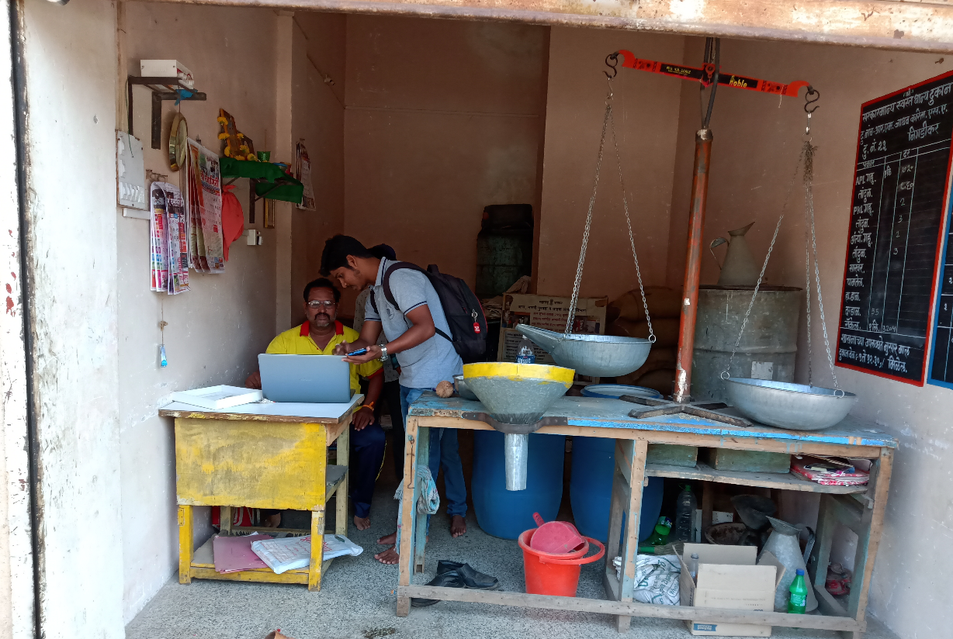

Fig. 5.1 Interaction with shop owner at field of deployment.

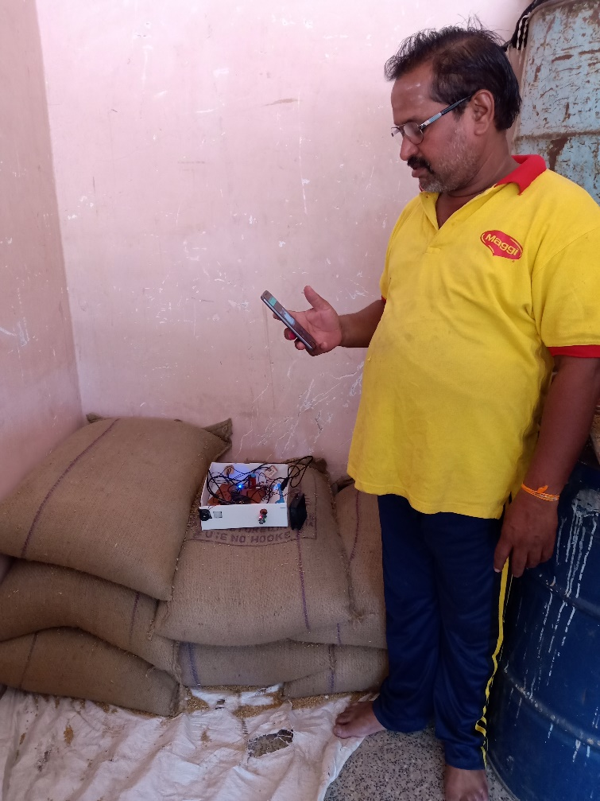

Fig. 5.2 Shop owner using system application.

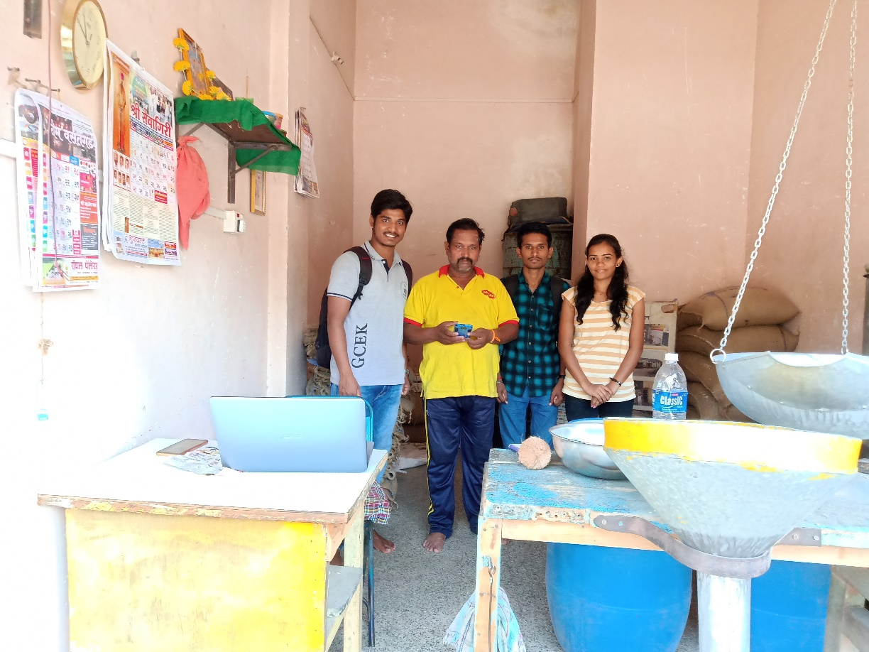

Fig. 5.3 Project team with shop owner.

**Chapter 6**

**RESULT AND DISCUSSION**

**6.1 Result:**

The intelligent grain storage management system is developed on the ESP8266 processor and the output is displayed on the ThingSpeak interface and blynk application. When the DHT11, MQ2 and MQ135 sensors are connected to the ESP8266 board then their respective values of temperature, Humidity and carbon dioxide percentage is shown as below.

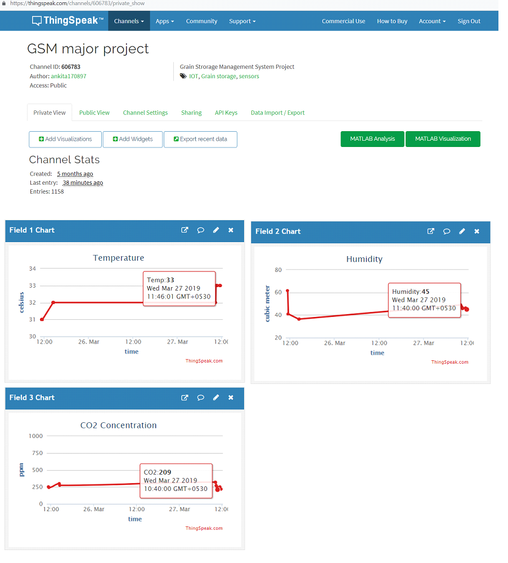

Fig. 6.1 Output on Desktop System

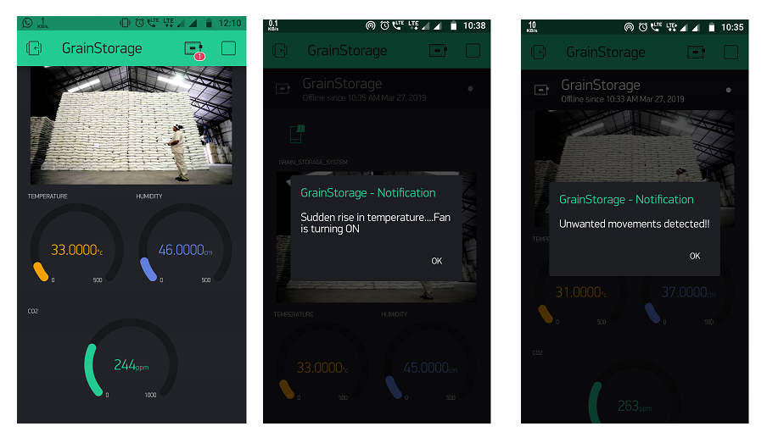

Fig. 6.2 Output on blynk application with notifications

**6.2 On-field Result Analysis:**

After deploying the Grain Storage Management System on real site, the various conditions are observed. The outputs are generated according to the environmental conditions of storage shop. As the storage area of shop was not provided with cooling facility and due to the summer season, the temperature of storage area is above 30º-35º C at the time of implementation. Other all parameters are within good range. Due to the high level of temperature the fan is turned ON in order to minimize and obtain the required sufficient temperature of cold storage. Hence, as a result, the temperature is decreased up to 28º C and it remains same for the next 5 hours of implementation. So, after monitoring the system, we have observed that the fan was automatically turned OFF. The others parameters such as moments of rats or other unwanted moments detection functionality also checked. The humidity and CO2 concentration results are captured and recorded into the feeds.csv document file. The owner also has been observed the results on their mobile and desktop application with remote notification feature.

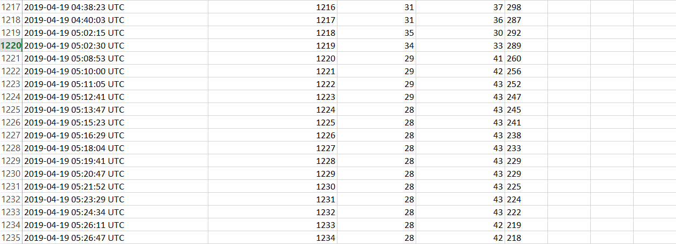

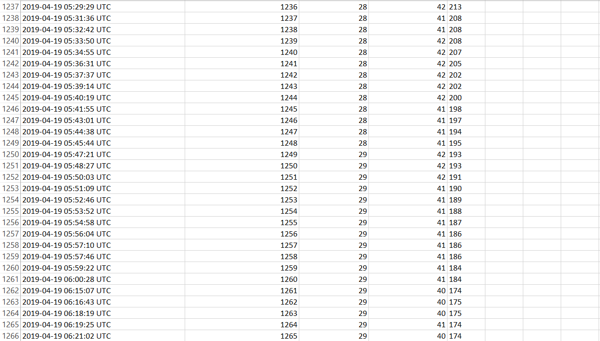

Fig. 6.3 Automatic generated Data sheet

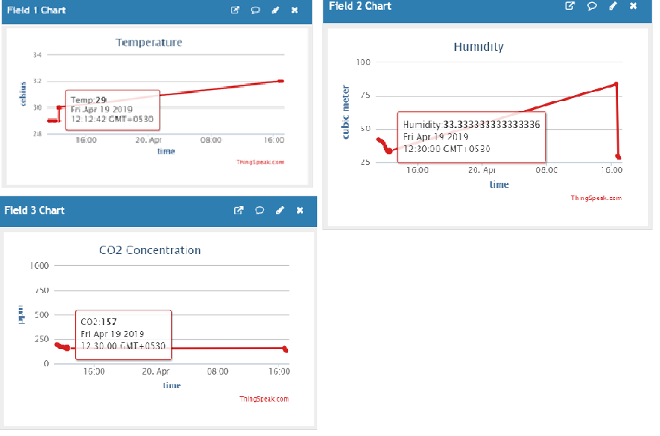

Fig. 6.4 Output on Desktop Application

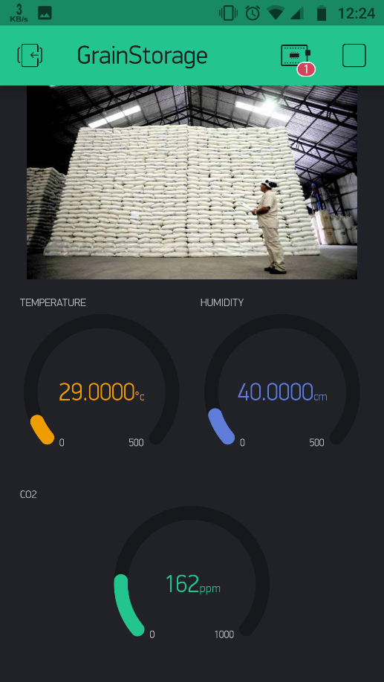

Fig. 6.5 Output on blynk application.

**6.2 Discussion:**

According to the author Vinayaka and Roopa of Intelligent System for monitoring and controlling grain condition based on ARM7 processor, the data captured is displayed on the LPC2148 and if the values are greater than threshold then commands are given to the vendor. But the proposed Intelligient grain storage system based on IoT not only captures the data but also takes the controlling actions over threshold conditions. And if the vendor is out of station then regular notifications will make him updated with the system continuously. The blynk application gives the snapshot of current situations regularly.

The methods are compared according to following parameters:

|  |  |  |
| --- | --- | --- |
| Parameters | Method 1:  Intelligent System for Monitoring and Controlling Grain Condition Based on ARM 7 Processor [1]. | Method 2:  Grain Storage Management System based on IoT**.** |
| 1.Hardware | ARM7 processor, LPC2148, LCD, Temperature sensor, Humidity sensor, gas sensor, GSM/GPRS module. | Esp8266, Smoke Sensor (MQ2), Carbon Dioxide Detector (MQ135), Motion Sensor (PIR), Digital Humidity Temperature Sensor (DHT11), Relay Module, Fan, Buzzer |
| 2.Software | Embedded system, MS chart | ThingSpeak cloud, Blynk application, Arduino IDE |
| 3.Display mechanism | LCD Display, Embedded application | Desktop System, Android application |
| 4.Advantages | Immediate result and less cost | Multiple functionality using multiple sensors. |
| 5. Disadvantages | Multiple parameters are not checked | Overall cost of project is more as compared to method 1. |

**Chapter 7**

**CONCLUSION AND FUTURE SCOPE**

**7.1 Conclusion**

The project Grain storage management system leads to the real-time system and the effective solution over the problem of grain storage management and the wastage arises due to not taking the proper maintenance. Hence, at the end of the project the issues regarding with storage and management of grain will be removed to great extent and the system can be maintained at proper environmental condition and with high quality levels. And after completion of system, it can successfully reduce the stored grain losses upto 80%. Ultimately, the food availability to the people in drastic conditions and in case of natural calamities is the moto of government and this project will surely help to fulfil that moto with less manual efforts and with more efficiency.

**7.2 Future Scope**

The project Grain storage management system can include the additional features in future as image processing and pattern analysis under machine learning. The camera implemented inside the go-down will capture the images of stored grain regularly on specified timestamp. Those pictures then will be analysed with the standard images in order to detect whether the grain is in proper condition or not. The results of pattern analysis will effectively maintains the status of grain and will inform the vendor in case on emergency.

**REFERENCES**

1. Vinayaka, Roopa’s “Intelligent System for Monitoring and Controlling Grain Condition Based on ARM 7 Processor” , PG Student in VLSI Design and Embedded System, Assistant Professor, Dept. Electronics and Communications, R.V College of engineering Bengaluru, India
2. Can Burak Sisman, Selcuk ALBUT’s “Grain Storage Management”, Namık Kemal Univ. Agricultural Faculty, Farm Constructions and Irrigation Dept. Tekirdag/Turkey
3. Shreyas S , Shridhar Katgar, Manjunath Ramaji, Yallaling Goudar, Ramya Srikanteswara’s “Efficient Food Storage Using Sensors, Android and IoT”, Student B.E, Department of CS&E Assistant Professor, Department of CS&E , ramya.srikanteswara@nmit.ac.in Nitte Meenakshi Institute Of Technology, Bengaluru.
4. Akila1, P. Shalini’s “Food grain storage management system”, Department of Computer Science, Vels Institute of Science Technology and Advanced Studies(VISTAS), Chennai, India. Department of MBA, Vels Institute of Science Technology and Advanced Studies (VISTAS), Chennai, India. Corresponding author E-mail:akila.scs@velsuniv.ac.in
5. Krushnali D. Bhosale, Renuka M. Chavan, Harshada D. Patil, Prof. Anagha Deshpande, “Noval Approach For Grain Storage System”, International Journal of TSGC, Tri-States Grain Conditioning, Inc., “Grain Temperature Monitoring Systems” www.tsgcinc.com
6. TSGC, Tri-States Grain Conditioning, Inc., “Grain Temperature Monitoring Systems” www.tsgcinc.